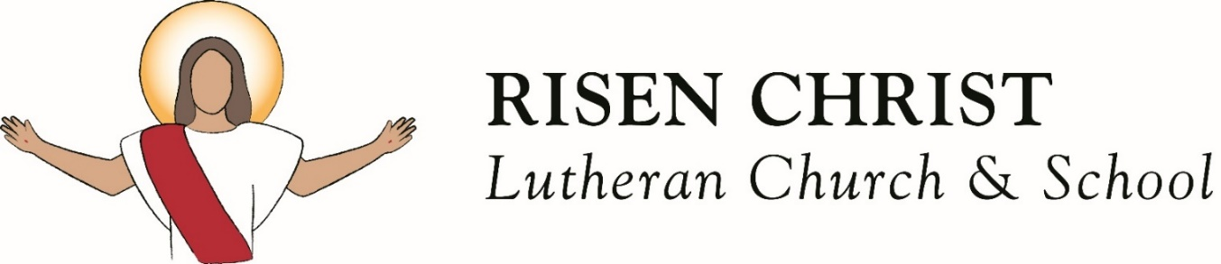

October 18, 2026 | Enriching and renewing lives by bringing Christ to our community | 10 am Service
Welcome
If you are a GUEST, thank you for worshiping with us today. Please introduce yourself to Pastor Scott and sign the Guest Book at the end of the row. First time visitors, be sure to stop at the Welcome Desk when leaving today to receive a special gift and more information about Risen Christ.

For children: There are "church bags by the main worship doors. Thank you for returning them after the service.
October 2026 Verse of the Month
And he said to them, "The harvest is plentiful, but the laborers are few. Therefore pray earnestly to the Lord of the harvest to send out laborers into his harvest."
Luke‬ 10‬:2‬ ESV‬‬‬‬‬‬‬‬‬‬‬‬‬‬‬‬‬‬‬‬‬‬‬‬‬‬‬‬‬‬‬‬‬

Today’s Sermon Title and Theme
“Faith Alone”
Philippians 3:8–9 & Romans 10:8–17 ESV
Theme: This month we are celebrating the 40th Anniversary of Risen Christ holding its first Bible Study on October 19, 1986, by focusing on the 4 Solas of the Lutheran Reformation: Scripture Alone, Grace Alone, Faith Alone, and Christ Alone. Today we focus on “Faith Alone”.
Order of Service
How Firm a Foundation | LSB 728, vs 1,2,3,5
All Sufficient Merit | B. Barnard, Fowler, S. Barnard
We Believe | Matthew Hooper, Richie Fike, Travis Ryan
Offertory: More Precious Than Silver | Lynn DeShazo1-2
When Peace, Like a River | LSB 673, vs 1-4

The Holy Bible, English Standard Version. ESV® Text Edition: 2016. Copyright © 2001 by Crossway Bibles, a publishing ministry of Good News Publishers

First Lesson: Genesis 15:1–6 ESV
1After these things the word of the Lord came to Abram in a vision: “Fear not, Abram, I am
your shield; your reward shall be very great.” 2But Abram said, “O Lord God, what will you give me, for I continue childless, and the heir of my house is Eliezer of Damascus?” 3And Abram said, “Behold, you have given me no offspring, and a member of my household will be my heir.”
4And behold, the word of the Lord came to him: “This man shall not be your heir; your very
own son shall be your heir.” 5And he brought him outside and said, “Look toward heaven,
and number the stars, if you are able to number them.” Then he said to him, “So shall your
offspring be.” 6And he believed the Lord, and he counted it to him as righteousness.

Second Lesson: Philippians 3:8–9 & Romans 10:8–17 ESV
8Indeed, I count everything as loss because of the surpassing worth of knowing Christ Jesus my Lord. For his sake I have suffered the loss of all things and count them as rubbish, in order that I may gain Christ 9and be found in him, not having a righteousness of my own that comes from the law, but that which comes through faith in Christ, the righteousness from God that depends on faith..

8But what does it say? “The word is near you, in your mouth and in your heart” (that is, the word of faith that we proclaim); 9because, if you confess with your mouth that Jesus is Lord
and believe in your heart that God raised him from the dead, you will be saved. 10For with the heart one believes and is justified, and with the mouth one confesses and is saved. 11For the Scripture says, “Everyone who believes in him will not be put to shame.” 12For there is no distinction between Jew and Greek; the same Lord is Lord of all, bestowing his riches on all
who call on him. 13For “everyone who calls on the name of the Lord will be saved.”
14But how are they to call on him in whom they have not believed? And how are they to believe in him of whom they have never heard? And how are they to hear without someone preaching? 15And how are they to preach unless they are sent? As it is written, “How beautiful are the feet of those who preach the good news!” 16But they have not all obeyed the gospel. For Isaiah says, “Lord, who has believed what he has heard from us?” 17So faith comes from hearing, and hearing through the word of Christ.

Gospel Lesson: Matthew 16:13–18 ESV
13Now when Jesus came into the district of Caesarea Philippi, he asked his disciples,
“Who do people say that the Son of Man is?” 14And they said, “Some say John the Baptist, others say Elijah, and others Jeremiah or one of the prophets.” 15He said to them, “But who
do you say that I am?” 16Simon Peter replied, “You are the Christ, the Son of the living God.” 17And Jesus answered him, “Blessed are you, Simon Bar-Jonah! For flesh and blood has not revealed this to you, but my Father who is in heaven. 18And I tell you, you are Peter, and on
this rock I will build my church, and the gates of hell shall not prevail against it.

Enriching and renewing lives by bringing Christ to our community
Phone: 937-323-3688 | Website: www.risenchristlcms.org
Pastor Scott Sommerfeld
Phone: 616-437-1891 | Email: pastor@risenchristlcms.org

Announcements
Fall Festival, Oct 23: Volunteers are needed to run games at the Fall Festival on Oct 23rd. Please contact Becky Reid at 937-831-0822 if you would like to volunteer.
LWML Miami Valley Zone Fall Retreat, Oct 24th: Saturday, Oct 24th is the Miami Valley Zone LWML Fall Retreat here at Risen Christ. Pastor Sommerfeld is our guest speaker. All ladies are invited to attend. If any questions, please contact Sara Hale.

Prayers for the Week
Denna Johnson
Upcoming Events
Oct 20: -Food Pantry – 11am- 1pm
-FROGs – 3:45pm
Oct 21: -Praise Team - 5:30pm
Oct 22: -YAM Bible Study – 7pm
Oct 23: -Fall Festival – 6pm
-Newsletter Deadline
Oct 24: -LWML Fall Retreat – 9am-12pm
-RCLC Meals – 5pm
Oct 25: -Education Hour - 9am
-Contemporary Sunday Worship
with Holy Communion – 10am

Diane Jeanneret

Home Bound
Jean Hawkins

Families of Risen Christ
ERVIN, BILL, BETH
ALISHA & ALEX
GALLAGHER, SUE & TERRY
HALE, GARY & SARA

 | Those Serving Today Oct 18 | Those Serving Oct 25
Elder | Chuck Bern | Rob Hunt
Greeter | Marcella Caskey | Kristy Vollrath
Ushers | Marcella Caskey Greg Shrader Paul Bok | Denny Norden Marcella Caskey Garrett Perks
Reader | Greg Shrader | Sandi Click
Altar Care | TBD | TBD
Sound Booth | Steve Rutledge | Marcus Cole
Counters | Denny Norden & Steve Rutledge | Steve & Deb Rutledge

